University Of Engineering and Technology, Lahore
Computer Engineering Department

Course Name: Programming Fundamentals | Course Code: CMPE-112L
Assignment Type: Lab Report | Dated:
Semester: 1st | Session: 2026 Spring
Lab/Project/Assignment #: 1 | CLOs to be covered: CLO
Lab Title: For Loop | Teacher Name: Hafiz Muhammad Mubashar
Lab Evaluation:

CLO1 | Apply appropriate programming techniques to create executable programs to solve well defined problems
 | Level1 | Level2 | Level3 | Level4 | Level5 | Level6
(5)
Total |  |  |  |  |  | /5
Rubrics for Current Lab Evaluation
Scale | Marks | Level | Rubric
Excellent | 5 | L1 | Submitted all lab tasks, BONUS task, have good understanding.
Very Good | 4 | L2 | Submitted the lab tasks but have good understanding
Good | 3 | L3 | Submitted the lab tasks but have weak understanding.
Basic | 2 | L4 | Submitted the lab tasks but have no understanding.
Barely Acceptable | 1 | L5 | Submitted only one lab task.
Not Acceptable | 0 | L6 | Did not attempt
LAB No 1
Lab Goals/Objectives:
• Understand the concept of for loops.
• Learn to repeat tasks using loops.
• Use range() with for loops.

Equipment Required:
• Computer/Laptop
• Python 3.x
• IDE (IDLE, VS Code, or PyCharm)

Theory:

A for loop is used to execute a block of code repeatedly for a fixed number of times or to iterate over a sequence such as a list, string, or range. It makes programs shorter, more efficient, and easier to read.

Lab Work:

For Loop:
Task 1:
binary = input("Enter a binary number: ")
decimal = 0
power = 0
for digit in reversed(binary):
decimal += int(digit) * (2 ** power)
power += 1

print("Decimal Equivalent =", decimal)

Result:

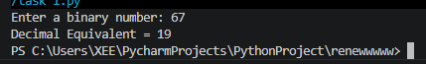

Task 2

sentence = input("Enter a sentence: ")

vowels = 0
consonants = 0

for ch in sentence:
ch = ch.lower()

if ch.isalpha():
if ch in "aeiou":
vowels += 1
else:
consonants += 1

print("Number of Vowels =", vowels)
print("Number of Consonants =", consonants)
Result:

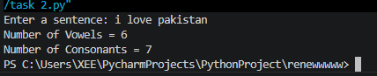

Task 3:
start = int(input("Enter starting number: "))
end = int(input("Enter ending number: "))

prime_sum = 0

print("Prime numbers in the given range are:")

for num in range(start, end + 1):
if num > 1:
is_prime = True

for i in range(2, num):
if num % i == 0:
is_prime = False
break

if is_prime:
print(num, end=" ")
prime_sum += num

print("\nSum of prime numbers =", prime_sum)

Result:

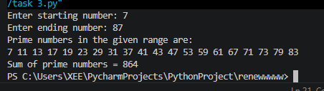

Task 4:
import random

uppercase = "ABCDEFGHIJKLMNOPQRSTUVWXYZ"
lowercase = "abcdefghijklmnopqrstuvwxyz"
digits = "0123456789"
special = "!@#$%^&*()_+-=[]{}|;:,.<>?/"

length = int(input("Enter password length: "))

use_upper = input("Include uppercase letters? (y/n): ")
use_lower = input("Include lowercase letters? (y/n): ")
use_digits = input("Include digits? (y/n): ")
use_special = input("Include special characters? (y/n): ")

characters = ""

if use_upper.lower() == "y":
characters += uppercase

if use_lower.lower() == "y":
characters += lowercase

if use_digits.lower() == "y":
characters += digits

if use_special.lower() == "y":
characters += special

if characters == "":
print("Error: You must select at least one character type!")
else:
password = ""

for i in range(length):
password += random.choice(characters)

print("Generated Password:", password)

Result:

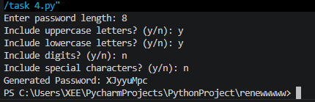

Task 5:

n = 4
for i in range(1, n + 1):
for j in range(i):
print("*", end=" ")
print()

for i in range(n - 1, 0, -1):
for j in range(i):
print("*", end=" ")
print()

Result:

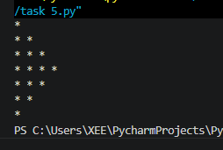

Task 6:
x = int(input("Enter total number of students: "))
for i in range(x):
print("Student", i + 1)
name = input("Enter your name: ")
obtained_marks = int(input("Enter obtained marks: "))
total_marks = int(input("Enter total marks: "))
percentage = (obtained_marks / total_marks) * 100
print("Percentage:", percentage)
if percentage >= 90:
grade = "A"
elif percentage >= 85:
grade = "A-"
elif percentage >= 80:
grade = "B+"
elif percentage >= 75:
grade = "B"
else:
grade = "C"

print("Grade:", grade)

Result:

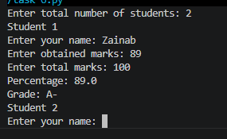

Conclusions:

In this lab, we learned how to use for loops to repeat tasks efficiently. We also understood how the range() function works and how loops simplify repetitive programming tasks.

